**Phase I**

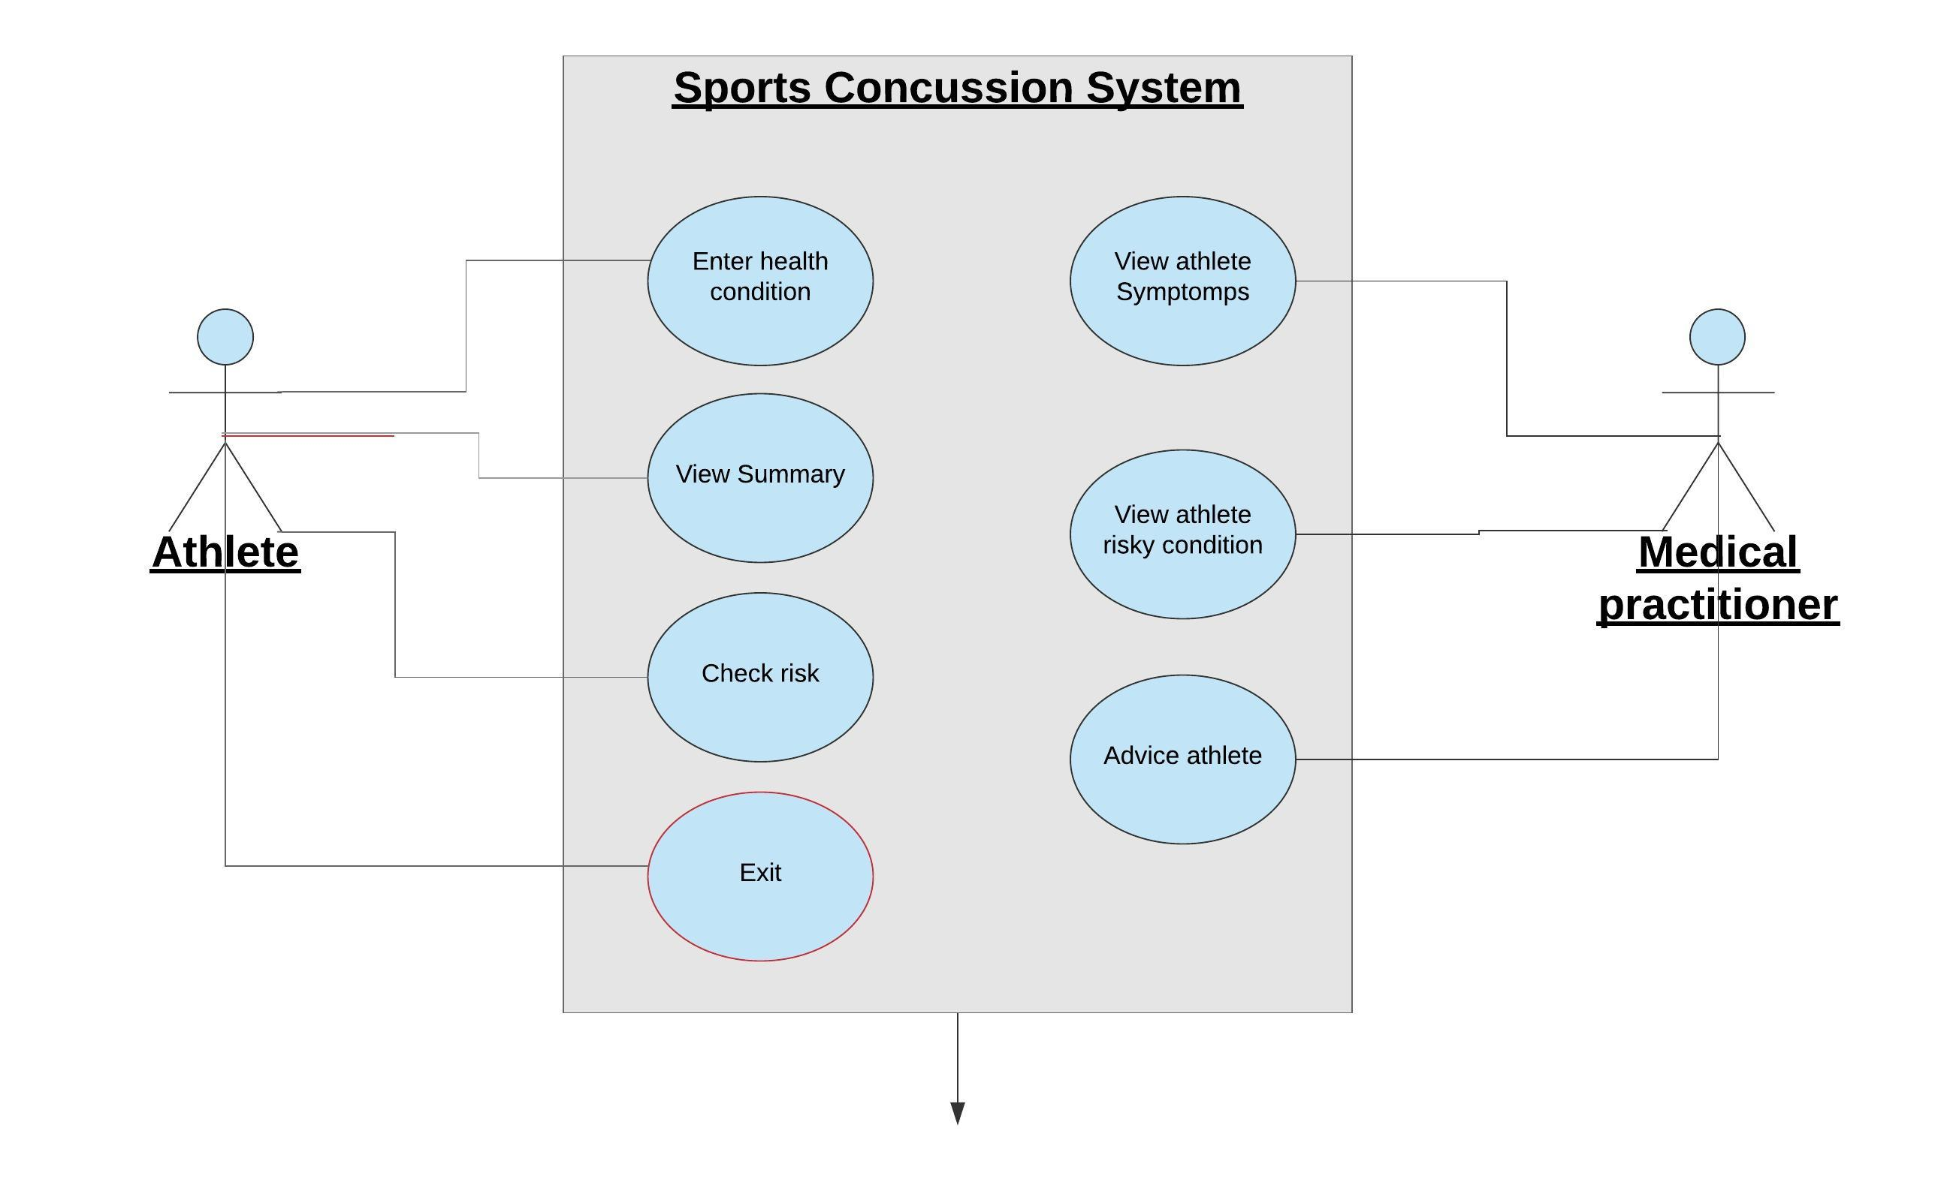  
Figure 1: Use case diagram

**Phase II**

|  |  |  |  |
| --- | --- | --- | --- |
| **Use Case Name**:Enter heath condition | **ID**: 1 | | **Importance level**: HIGH |
| **Primary Actor**: athlete | | **Use Case Type**: Real, Detail | |
| **Stakeholders and Interests**:  Medical practitioner – wants to advice the athlete | | | |
| **Brief Description:** Describe process of inserting medical condition | | | |
| **Trigger**: Athlete wants to insert symptoms  **Type**: Temporal | | | |
| **Relationships**:  **Association**:  **Include**:  **Extend**:  **Generalization**: | | | |
| **Normal Flow of Events**:   1. Launch the system 2. Choose to enter symptoms 3. Enter your score of the symptom | | | |
| **Sub flows:** | | | |
| **Alternate/Exceptional Flows**:  3. If the athlete keys in a number less than 0 or more than six, we would continue prompting until he/she keys in the right info | | | |

|  |  |  |  |
| --- | --- | --- | --- |
| **Use Case Name**: view summary | **ID**: 1 | | **Importance level**: HIGH |
| **Primary Actor**: Athlete | | **Use Case Type**: Real, Detail | |
| **Stakeholders and Interests**:  Athlete: Athlete wants to view summary of his heath condition | | | |
| **Brief Description:** show steps for viewing summary | | | |
| **Trigger**: athlete selects option two from the menu  **Type**: Temporal | | | |
| **Relationships**:  **Association**:  **Include**:  **Extend**:  **Generalization**: | | | |
| **Normal Flow of Events**:   1. Launch the system 2. Choose the option 2: | | | |
| **Sub flows:** | | | |
| **Alternate/Exceptional Flows**:  4a. If athlete enters a number less than one or more than 4; treprompt for the right value | | | |

|  |  |  |  |
| --- | --- | --- | --- |
| **Use Case Name**: Check risk | **ID**: 1 | | **Importance level**: HIGH |
| **Primary Actor**: Athlete | | **Use Case Type**: Real, Detail | |
| **Stakeholders and Interests**:  Athlete: needs to know level of risk | | | |
| **Brief Description: d**escribes the steps iused to check if the athlete is at risk | | | |
| **Trigger**: athlete selects option 3  **Type**: Temporal | | | |
| **Relationships**:  **Association**:  **Include**:  **Extend**:  **Generalization**: | | | |
| **Normal Flow of Events**:   1. Launch the system 2. Choose the option 3 | | | |
| **Sub flows:** | | | |
| **Alternate/Exceptional Flows**:  4a. If athlete enters a number less than one or more than 4; the athlete is prompted to re enter a choice | | | |

**CRC card**

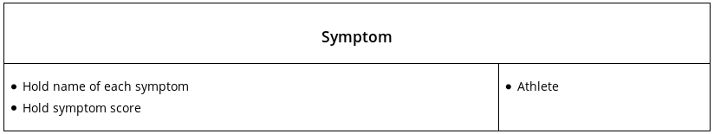

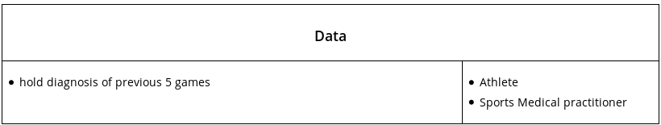

**Class Diagram**

